**4. INTERNAL ANALYSIS**

(a) Current strategy

1. **Reinforce the Electronics Business**

* Accelerate execution of updated strategies in the three core businesses (Mobile, Imaging and Gaming)
* Return the TV business to profitability
* Accelerate the execution of growth strategies in emerging markets that leverage the overall strength of the Sony Group
* Reinforce new businesses (such as Medical and Security) to deliver sustained growth
* Further realign Sony’s business portfolio

1. **Further strengthen profitability in the Entertainment and Financial Services businesses**
2. **Continue to reinforce Sony’s financial foundations**

(b) Activities

SONY supply chain

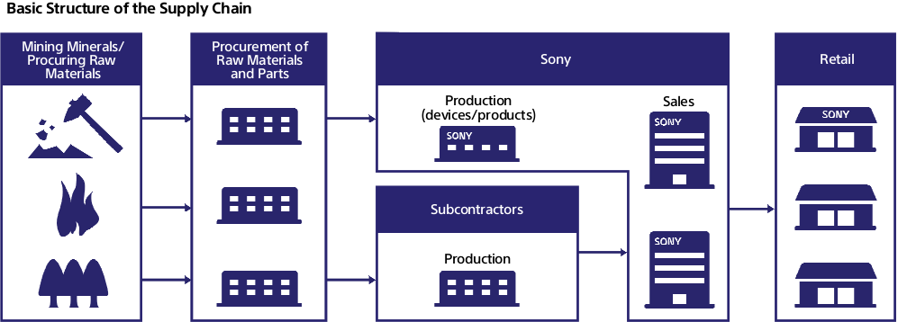

Sony is adopting supplier selection criteria to improve its supply chain vetting process.

These criteria include the Green Partner Standards (in which each supplier must pass the Green Partner audit) and Sony’s own Supplier Code of Conduct (which is based on the EICC Code of Conduct). In addition Sony has implemented supplier questionnaires and has established a catalog of approved green office supplies. This clearly articulates to suppliers what Sony expects in terms of operational sustainability and supports what is known as the business scorecard.

The business scorecard works as an incentive by providing a clear evaluation model and supplier code of conduct to inform the suppliers that if they do not meet these expectations, they could lose Sony’s business.

Through adopting a serious approach to sustainable supply chain management, Sony strengthened the resiliency of its supply chain, avoided costs incurred from business disruption and generated business value in the process.

Sony has a dedicated supply chain solutions company that handles the logistics networks that connect manufacturing/sales based in Japan and overseas. They also establish a consistent system in order to produce an efficient supply chain for the Sony Group.

Here are the four main businesses under management of Sony Supply Chain Solutions, Inc.:

Sony Supply Chain Solutions, Inc. exerts all their expertise of procurement, logistics and repairs to help improve the business performance of Sony and to achieve unsurpassed efficiency of operations.

VALUE CHAIN IN DESCRIPTIVE DETAIL FROM SONY

Support Activities:

* Firm Infrastructure

With several years’ loss for net income, Sony need to optimize their resources and realigning their business portfolio. The management plan restructures Sony into a smaller, more focused company.

In order to increase efficiency and reinforce Sony’s business infrastructure, Sony implemented structural reforms including optimizing resources and streamlining marketing organization in developed markets, consolidating certain manufacturing operations in japan and expediting measures to reduce headquarters headcount.

* Financial Management

Through sales of low profit business and assets, focusing on core business and creating high profit business, Sony is trying hard to make profit and turn around their sales and business operations.

* Technology Development

From acquiring patent and assets from other companies, Sony is able to create high profit products and take over markets in a short time. Cooperating with other companies, sharing technologies and research is also a good way of technology development.

High-end technology is one of most important assets of Sony, like the CMOS imaging sensors Even Nikon and Apple are using Sony’s technology imaging technology. Another of Sony’s important assets is their ability to innovate. Unleashing the creativity of their employees may help Sony make revolutionary products like before.

* Procurement

Sony has adopted a supplier code of conduct, based on industry best practices as highlighted in the EICC code of conduct. All Sony suppliers must comply with the code of conduct.

Sony also supports the corporate social responsibility initiatives of its suppliers through a system of assessment and monitoring to verify compliance with the Sony Supplier Code of Conduct. Sony’s efforts include risk assessments, follow-up meetings with suppliers to discuss assessment results and third-party audits.

Sony has established the Green Partner Environmental Quality Approval Program, which it uses to certify suppliers that comply with Sony’s standard for management of chemical substances as “Green Partners.” Each supplier must pass the Green Partner audit.

Primary Activities:

* Inbound logistics and distribution

Sony engages in a series of complex in-bound logistics activities.

Sony usually controls the entire flow of goods by design including the materials chosen. It is more flexible for Sony to make schedules, choose standards and deal with wholesalers or retailers.

As the company expands, Sony also engages 3rd parties such as Hon Hai Precision Industry Co. to manufacture some of its product components (PlayStation 4) so that the company will continue to engage in its core competencies and research & development.

* Operations

There are lots of sub companies and partners supporting Sony’s operations.

For example, Sony has a dedicated supply chain solutions company that help Sony Group operate more efficiently.

Sony’s businesses span across multiple continents. For possession of local markets and talents, Sony built manufacturing facilities, R&D labs and sales offices all over the world.

* Outbound distribution & Logistics

A manufacturer wanting to distribute its goods directly to customers must not only have the production capability, but also the ability to market and efficiently distribute goods.

Using dedicated software like SAP or WIZE at a distribution center will help Sony acquire information on the storage and movement of the final product as well as the related flows from the end of the production line to the end user. This includes location, quality, date, employees and more.

Responsible and initiative employees combine with modern technology is the key to improve the quality of outbound distribution & logistics.

* Marketing Sales and distribution

Sony is involved in many sport, music and charity events to build up a positive image.

Commercial advertising is important and traditional way to motivate people into purchasing Sony’s products. To build brand name image by placement Sony’s image into movies or TV shows is common.

Sony Store (Sony’s first party retail locations) are a good way to introduce new products and enhance the brand image. But with the high cost of maintenance, impact from local retail and online retail, Sony has to carefully choose when to close or open a Sony Store. In an effort to further streamline costs and continue focus on existing partner relations, Sony announced the closure of 20 U.S. Sony Stores.

* After Sales Service

Sony has built their traditional customer service network over decades and it is now a mature system. In the digital age there is more than one way to do after sales services. End users can setup online chat or email to address issues. Users can also interact with Facebook and Twitter. Social media allows Sony to understand what their customers need/want.

(c) Resources & Capabilities

1. What are the current resources for the organization?

* Financial Resources

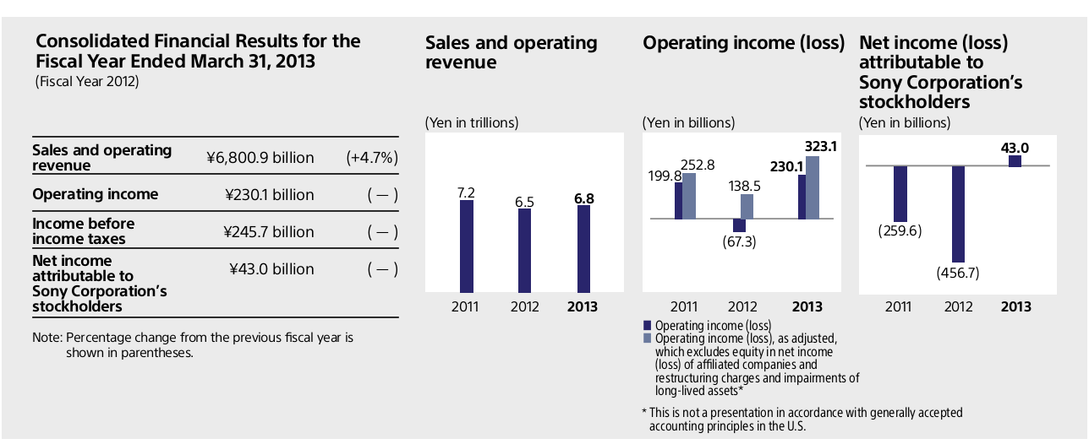

From the annual report for fiscal year 2012, Sony’s sales and operating revenue reached $72.3 billion US dollar (4.7% above the previous year). The increase of operating revenue was due to consolidation of formerly Sony Ericsson Mobile Communications AB as a wholly-owned subsidiary, a favorable foreign exchange rate and financial services revenue growth. Another positive impact of operating revenue was the sale of the chemical products business and U.S. headquarters building in New York City.

The most sales revenue of Sony come from digital imaging, games, picture and financial services. Televisions and Sounds lost about 897 million US dollars. Compared to the operating income loss of last fiscal year, there are 2.5 billion in profits. However some of the operating income comes from the sale of office building. At end of fiscal year of 2012, SONY turned a profit for the first time in 5 years. It achieved a net income of 458 million US dollars. This is good news for SONY, but with powerful competitors like Apple and Samsung, with narrowing market and products profit Sony’s financials still face a big challenge in the near future.

SONY predicts they will achieve $507 million USD net income for the fiscal year of 2013. Based on the PlayStation 4 release and huge smart phone demand. Besides, SONY plans to publish “High value-added products” to make the television business return to profitability.

* Physical

After many years of expansion and financial crisis, SONY has to reconstruct the company’s infrastructure and product lines. Sony aimed at creating new businesses while strengthening core businesses.

On June 5, 2006 SONY entered the high profits digital imaging market by announcing their first ever DSLR camera. Sony had previously acquired Konica-Minolta's photography business in early 2006. Between 2006 and 2008 Sony was the fastest growing company on the DSLR market, reaching 13% market share in 2008 to become the third largest DSLR Company in the world, behind only Canon and Nikon. Under this circumstances, Sony decisions on investment to expand their CMOS image senor manufacturing capacity.

On October 27th, 2011 Sony announced that it would acquire Ericsson's stake in Sony Ericsson for €1.05 billion ($1.47 billion), making the mobile handset business a wholly owned subsidiary of Sony. Sony Mobile was the fourth largest smartphone manufacturer by market share in the fourth quarter of 2012 with 9.8 million units shipped.

As one of core businesses, Sony continues invested substantially in the game business, PlayStation 4 and PlayStation VITA will take direct challenges from Microsoft’s XBOX ONE, Nintendo’s 3DS and Apple’s iPhone.

In 2012, Sony acquired Gaikai Inc., a U.S-based developer that provides interactive cloud-based gaming services. This acquisition will help Sony build a secure and stable way enhance the service and function of the PlayStation network.

In 2012, Sony also established Sony Olympus Medical Solution Inc. (a joint venture with Olympus Corporation) that plans to deliver new innovative medical products such as surgical endoscopes and a new medical imaging systems solutions business.

Sony continues shut down their factories in order to reduce labor cost. They are shifting most of their mid to low level manufacturing and assembly factories overseas or outsourcing to 3rd party manufacturers.

As one of the biggest electronics companies, Sony certainly has large and unique physical resources. But not all of them could create value, Sony needs to optimize its physical resources for its core businesses and create high profits businesses.

* Human resources

SONY recognizes its employees are one of the most crucial aspects of its corporate foundation.

During Sony’s early stages, their managers developed a healthy relationship with their employees, creating a family-like feeling within the corporation. This is a feeling that employees and manager share the same goals. They created conditions where people could come together in a spirit of teamwork, and exercise their technological capacity. Sony need continue and reinforce the tradition of this principle.

Since then Sony has become one of the biggest international companies. Respect and appreciation for diversity is another of its principal strengths. Guided by the concepts of diversity and inclusion Sony is recruiting, hiring, training and promoting employees from various backgrounds. Mixing cultures and work environment suit the trend of globalization helping Sony to quickly adapt and occupy local market in different countries.

Sony enhances individual abilities and develops specialized skills that are tailored to local needs by offering on-the-job learning, as well as a variety of programs. Sony strives to create positive working environments and opportunities that enable individuals with diverse backgrounds to fulfill their potential by learning from one another, believing these to be essential to a rewarding corporate climate. Through education of employees and communication between employees, Sony is able to maximize the chances of talents discovery and adapt faster to changes in the market.

How to unleash employee’s inborn creativity, how to create a satisfactory work place where employees are happy and proud about their work is something Sony’s HR need to focus on.

* Organizational

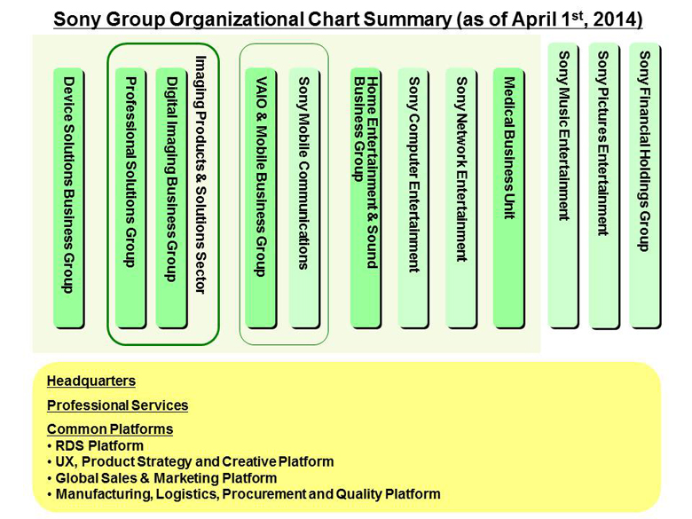

In order to drive revitalization and growth of the electronics businesses and deliver compelling user experiences as “One Sony”, Sony established a new management structure. These changes are intended to drive revitalization and growth across Sony's core electronics businesses, and deliver compelling user experiences through convergence of the unique assets in place throughout the Sony Group.

Sony divides their business into two main groups: electronics group and entertainment & financial services group. Sony also setup UX (user experience), product strategy and create platform as common platforms, to achieve high degree of integration between hardware and software, push compatibility between different product, and enhance entertainment content and service.

Sony plans to reinforce the traditional electronics business by focusing on Sony’s three core electronics businesses - mobile, imaging and gaming. Sony merges consumer business and professional business together. By integrating product development with the same technology and project implementation in the same market, Sony could utilize their resource as best as possible. This will help Sony save lots of time and money. Sony is also able to take advantage of this structure, improving the competitiveness of their products.

Entertainment and financial services businesses already contribute stable profit. Sony needs improve profitability of them. From the change of organizational structure, we catch sight of Sony’s strategy to integrate core business, to enhance business on services and applications and reducing unnecessary products lines.

* Technological Resources

“Sony is a technology company with an intimate understanding of the creative possibilities of content. Sony is a content company with an intuitive grasp of technology. No other company has both.” -Sir Howard Stringer, Chairman, CEO and President

Sony has historically been notable for creating its own in-house standards for new recording and storage technologies instead of adopting those of other manufacturers and standards bodies. Sony (either alone or with partners) has introduced several of the most popular recording formats, including the floppy disk, Compact Disc, and Blu-ray Disc.

After the year 2000, when Samsung and Apple were taking advantage of the digital technology Sony still insisted on using their own formats, like the MiniDisc player. Sony lost the first battle of digital war, although Sony’s technology is second to none, but Sony cannot follow the beaten track anymore, it need broken conservative and complacent.

With the success of Blu-ray, Sony understands that cooperation with other companies will reduce marketing risk and development cost. After the huge cost to develop the cell microprocessor on PlayStation 3, Sony understands that embracing open formats and high compatibility is not only about saving resources and expanding markets, it’s also a trend of the digital age. When Sony officially announced the PlayStation 4, people found the technology in the PlayStation 4 is relatively similar to the hardware found in personal computers. Sony is also more advanced in producing consumer electronics products than its competitors. For instance, the PlayStation 4 offers a substantial jump in performance with slim size compared to the Xbox One.

In the digital age the technological gap between Sony and their competitors is small. The advantage of Sony is good at balancing technology and design, and making better quality products with same resources compare to their competitors.

* Innovation

“The key factor in industry is creativity. I said there are three creativities: creativity in technology, in product planning, and in marketing. To have any one of these without the others is self-defeating in [business](http://en.wikiquote.org/wiki/Business).”- Akio Morita

Innovation was the key to making Sony different compared to other companies. It’s the foundation stone of Sony’s values. It allowed Sony to dominate the electronics market and change people's lives for decades.

Through innovation Sony had produced many revolutionary products that include the first magnetic tape and tape recorder in 1950; the transistor radio in 1955; the world’s first all-transistor TV set in 1960; the world’s first colour videocassette recorder in 1971; the Walkman personal stereo in 1979; the Compact Disc (CD) in 1982; the first 8mm Camcorder in 1985; the Minidisk (MD) player in 1992; the PlayStation game system in 1995; Digital Mavica camera in 1997; Digital Versatile Disc (DVD) player in 1998; and the robot dog Aibo as well as Network Walkman digital music player in 1999 (Sony.com/en/corporate). These innovations have created new markets of their own.

In 2012 Sony unveiled the DSC-RX1. This is notable for being the world's firstfixed-lens, [full-frame](http://en.wikipedia.org/wiki/Full-frame_digital_SLR) digital [compact camera](http://en.wikipedia.org/wiki/Compact_camera) and as of its announcement, it is the world's smallest full-frame digital camera. Sony DSC-RX100 has also been named as the 'European Advanced Compact Camera for 2012–2013' by the [European Imaging and Sound Association](http://en.wikipedia.org/wiki/European_Imaging_and_Sound_Association) (EISA). It has also been named one of the Best Inventions of 2012 by Time Magazine. 

With decades of technology accumulation and its own tradition, Sony has capability to keep innovate and surprise customers with innovate. This helps Sony enhance the sales and brand image.

* Reputation

“Sony could make 80,000 bricks and people would buy them.”- Bill Gates

A good reputation is more valuable than money. Sony was a synonym for superior quality and expensive.

There are millions of people using Sony’s products every day. Cutting edge technology, elaborate design, advanced engineer deeply influence people, create Sony’s brand loyalty.

In 2012, Reputation Institute (a global private consulting firm based in New York) recently ranked 100 businesses that have successfully established strong international names for themselves. The firm invited about 47,000 consumers across 15 markets to participate in a study of those 100 most reputable companies, all multinational businesses with a global presence. Sony earned a 79.31 global score and the number 2 ranking. BMW ranked first. Sony has its strongest reputation for its high quality products, but also ranks in the top 10 on all the other measured dimensions. The weakest spot for Sony is the perceptions on citizenship, where its score fell below 70 on the global level.

In the digital age, people have more choices than before. Sony is also facing strong challenge from Samsung, Apple or other new rising brands, but the “Sony” brand is still one of the world’s most recognisable and trusted brands.

1. Which of these resources has been activated; that is, is a deeper capability?

|  |  |  |  |  |  |  |  |
| --- | --- | --- | --- | --- | --- | --- | --- |
| Benchmark resources & capabilities relative to the industry competitors | | | | | | | |
|  |  | **SONY** | | **Apple** | | **Samsung** | |
| RESOURCES& Capability | Importance  Weight | Relative Strength | Score | Relative Strength | Score | Relative  Strength | Score |
| R1.Finance | 0.05 | *6* | *0.3* | *10* | *0.5* | *8* | *0.4* |
| R2. Physical | 0.05 | *9* | *0.45* | *7* | *0.35* | *9* | *0.45* |
| R3. HR | 0.1 | *6* | *0.6* | *8* | *0.8* | *7* | *0.7* |
| R4. Organizational | 0.1 | *8* | *0.8* | *8* | *0.8* | *8* | *0.8* |
| R5. Technological | 0.1 | *9* | *0.9* | *9* | *0.9* | *7* | *0.7* |
| R7. Innovation | 0.2 | *8* | *1.6* | *10* | *2* | *8* | *1.6* |
| R8. Reputation | 0.1 | *9* | *0.9* | *9* | *0.9* | *7* | *0.7* |
| C1. Purchasing | 0.05 | *7* | *0.35* | *9* | *0.45* | *8* | *0.4* |
| C2.Engineerng | 0.1 | *9* | *0.9* | *9* | *0.9* | *8* | *0.8* |
| C3. Marketing &sales | 0.1 | *9* | *0.9* | *10* | *1* | *9* | *0.9* |
| C4. Govt. Rel. | 0.05 | *8* | *0.4* | *7* | *0.35* | *9* | *0.45* |
| Sum of importance weights | 1.0 |  |  |  |  |  |  |
| **Weighted overall strength rating** |  |  | *8.1* |  | *8.95* |  | *7.9* |
| *Strength and score scale range from 1 to 10 (1=very low, 10=Very high)* | | | | | | | |

1. (d) The Underlying Business Model or “Value Proposition”

Sony did not have a specific or clear value proposition in that Sony tries to create an impression to the public that Sony is the best in every direction.

On the other hand, when we talk a specific Sony product, we usually can find the value proposition of it. For example, at end of 2006 when the PlayStation 3 was released, Sony claimed the PlayStation 3 was the cheapest Blu-Ray player in the market. We also could find different value propositions for the same product. In a subsequent promotion of the PlayStation 3, Sony offered free online game play. This became one of the most important value propositions of the PlayStation 3.

<http://www.sonyscs.co.jp/english/business/index.html>

http://www.sony.net/SonyInfo/News/Press/201305/13-065E/

http://www.forbes.com/sites/jacquelynsmith/2012/06/07/the-worlds-most-reputable-companies/2/

http://www.driveyoursuccess.com/2012/06/b2b-value-proposition-five-essential-criteria-for-success.html

http://en.wikipedia.org/wiki/Sony_Cyber-shot_DSC-RX100

<http://www.theverge.com/2014/2/26/5451012/sony-closing-majority-of-us-retail-stores-by-end-2014>

*http://www.destructoid.com/sony-s-new-philosophy-is-make-believe--147351.phtml*